DDS DS 6306 Project 2: Abalone Age

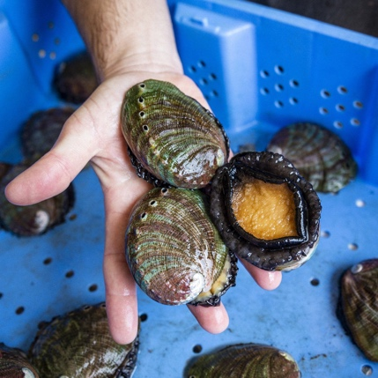

Introduction
- Objective A: Your task is to use linear regression to predict the age of abalone given physical attributes. Good luck!
- Objective B: Analyze the data to uncover key factors or relationships that contribute to predicting the age of abalone. Any other interesting or useful discovered relationships will be of value as well!
- Objective C: Create an application that uses RAG to let a user ask questions about the abalone using natural language. You can deploy it using Hugging Face Spaces.
- Objective D: Publish all of this to your github.io website or to your personal website if you so choose.

Objective A: Building a Predictive Model
The primary objective is to develop a robust predictive model that accurately predicts abalone age based on various features. We aim to achieve the lowest possible Mean Absolute Error (MAE) on the test set, ensuring high precision in our predictions.
Mean Absolute Error (MAE) is a commonly used metric for evaluating regression models. It measures the average magnitude of errors in a set of predictions, without considering their direction. The formula for MAE is:
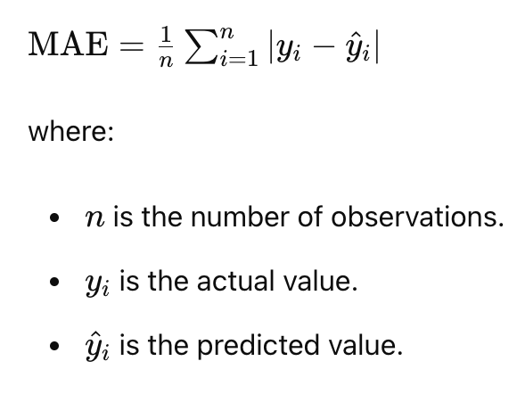
Minimizing MAE ensures that our model predictions are as close as possible to the actual values, providing a reliable tool for assessing wine quality.
The student with the lowest MAE on the test set will win an extra 5 points on the project and Bragging Rights!

Objective B: Mining Data for Insights
Beyond prediction, this project aims to delve into the dataset to identify the key determinants of abalone age. By analyzing the relationships between various abalone metrics and age, we can provide valuable insights to help scientists understand their growth rate, reproductive cycles, and lifespan which can help commercial markets as well as scientific studied into climate change, effects of ocean pollution, shifts in predatory trends, etc.

Objective C: RAG App
Create an application that uses RAG to let a user ask questions about the abalone using natural language. You can deploy it using Hugging Face Spaces.
Objective D: github site

Publish all of this to your github.io website or to your personal website if you so choose.



Feature Details:

Input variables:
Sex
Length
Diameter
Height
Weight
Shucked Weight
Viscera Weight
Shell Weight
Output variable (based on sensory data):
Age

Dates:

Final Project Deadline: Sunday, December 14th at 11:59pm CST

Deliverables:

- 7 min recorded group presentation with the link posted on this Google Doc:
https://docs.google.com/document/d/1MRuxsni4HiRLY6Irr1ZPSoGWgItbmYUdh3MVWki5URI/edit?usp=sharing

- Predicted ages of abalones for the competition set. This should be in CSV format and should have two columns: ID and age.

- RShiny Dashboard that is useful in highlighting and exploring relationships between abalone age and the recorded features.
- Rmarkdown that describes your analysis. Knit to pdf or Word doc.

- GitHub Repo with all files that pertain to the deliverables above.

- RAG App

- github.io website with this project in the projects section along with the RAG app, RShiny app link and html of the write up.

Please reach out to your partner via email asap to establish the lines of communication.

